**Application for Student Enrollment**

**Please submit your completed application to Chester County Futures**

**All three of the following must be included:**

* Parent Application including:
  + Income Verification
  + Total annual parental or guardian financial
  + Student Residency Verification

**Parent Application**

**Name of Student**: _________________________________________________ Date: _____________________________

(Please Print)

**Total Household Gross Income – Attach current income tax return (1040)**

|  |  |  |  |  |  |  |  |  |  |
| --- | --- | --- | --- | --- | --- | --- | --- | --- | --- |
| Name List everyone in household and the income each earns OR check the box at the right if they have no income | Include current pay stub |  | Welfare, Child Support, Alimony |  | Pension, Social Security Disability |  | Other income: self-employed, unemployment |  | Check if NO income |
| **Name** | **Gross Income** | **Frequency** | **Income** | **Frequency** | **Income** | **Frequency** | **Income** | **Frequency** |  |
|  |  |  |  |  |  |  |  |  |  |
|  |  |  |  |  |  |  |  |  |  |
|  |  |  |  |  |  |  |  |  |  |
|  |  |  |  |  |  |  |  |  |  |
|  |  |  |  |  |  |  |  |  |  |
|  |  |  |  |  |  |  |  |  |  |
|  |  |  |  |  |  |  |  |  |  |
|  |  |  |  |  |  |  |  |  |  |
|  |  |  |  |  |  |  |  |  |  |

Total number in household: ________ Total amount of gross household annual income: _____________

**Name of Parent/Guardian: (Please Print) _________________________________________________**

**Signature of Parent/Guardian: _________________________________________________________**

**The following documentations are needed to complete this application:**

**Documents:**

Most Recent Income Tax Return (1040) ____

Last two pay stubs for parents/guardians in household____

Copy of **one** of the following:

* Student Birth Certificate____
* Current Green Card____
* Social Security Card____
* Passport with Current Visa____

**Please answer all questions thoroughly and attach the necessary documentation. Email all portions of the completed application and documentation to** [**mwilliams@ccfutures.org**](mailto:mwilliams@ccfutures.org) **or mail to 50 South 1st. Avenue, Suite 105, Coatesville, PA 19320**

**Upon receipt of the completed application:**

* Chester County Futures (Futures) staff will set up phone interviews to determine student eligibility   
  for the program.
* If a student is accepted into Futures, the parent and student will receive a notice in writing.
* A representative from Futures may be in touch with you if there are any questions regarding this application.

**Sample Documents Needed With Complete Application**

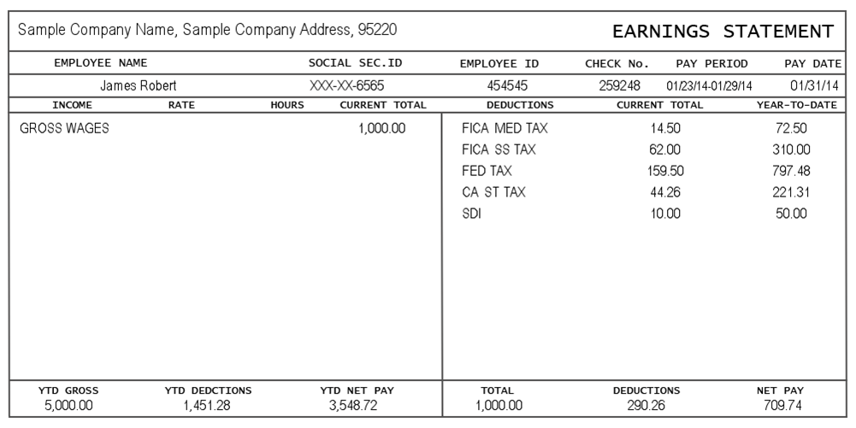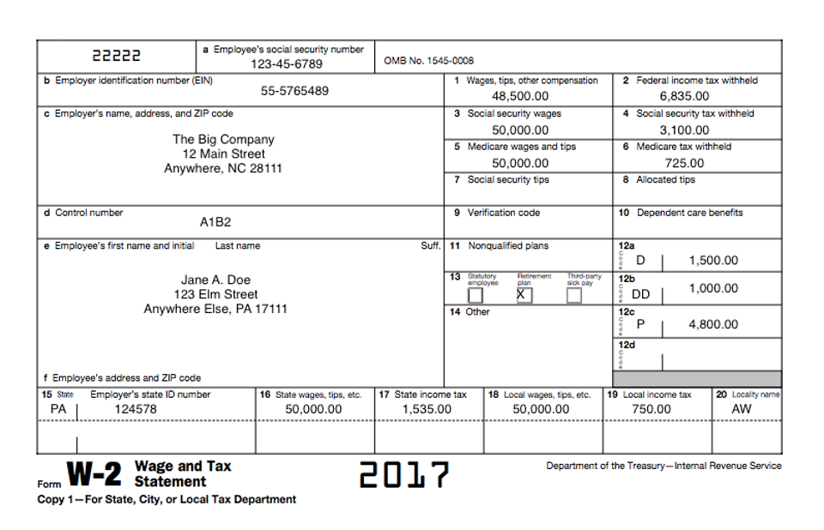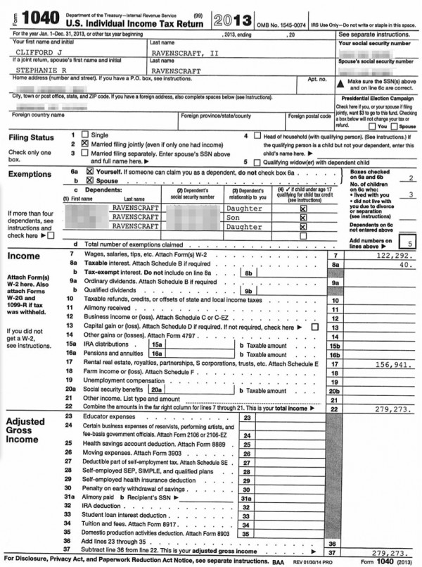

**Student’s Name: ______________________________ Date of birth: ______/______/______**

**Parent/Guardian Information:**

**Name of Parent/Guardian(s):** (Please print) **Address**

_______________________________________ ______________________________________________ _______________________________________ ______________________________________________

How many Parents/Guardians live in the home? __________

**Phone:**

Mother: Home: ____________________ Cell: _______________________ Email: ____________________

Father: Home: ____________________ Cell: _______________________ Email: ____________________

Student: Home: _____________________ Cell: _______________________ Email: _____________________

**Mother/Guardian’s highest level of education completed**: (Please check)

Elementary: ____ Middle School: ____ High School: ____ Technical School: ____ College: ____ Graduate School: ____

Degree received? Yes ___ No___ If yes, list degree: _________________________________________

**Father/Guardian’s highest level of education completed:** (Please check)

Elementary: ____ Middle School: ____ High School: ____ Technical School: ____ College: ____ Graduate School: ____

Degree received? Yes ___ No___ If yes, list degree: _________________________________________

**Please list all members of your household and their relationship to the student:**

**Name**  **Relationship**

____________________________________________________________________________________________________________________________________________________________________________________________________________________________________________________________________________________________________________________________________________________________________

What is the primary language spoken in the household? ___________________________________________

Do you have access to the Internet in your household (Please circle)? Yes or No

Are any of these technology devices used in the home? (Check all that apply)

__ Ipad __ Smart Phone __ Computer __ Other:___________________

**Ethnicity:**

__Hispanic

__Caucasian

__African American

__Asian

__Native American

__Other:____________________________

**Parent/Guardian place of employment, if applicable:**

Mother: _____________________________________________________________________

Work Phone Number: ___________________________________________________________

If necessary, may we call you at work? Yes ____ No ____

Father: ______________________________________________________________________

Work Phone Number: ___________________________________________________________

If necessary, may we call you at work? Yes ____ No ____

**How do you expect Chester County Futures to help your son or daughter?**

_____________________________________________________________________________________________________________________________________________________________________________________________________________________________________________________________________________________________________________________________________________________________________________________________________________________________________________________________

_________________________________________________________________________________________

_____________________________________________________________________________

_____________________________________________________________________________

**Parent/Guardian Release of School Records**

**Date:** ________________________

Please complete and sign the form below giving authorized Futures’ staff access to review your child’s school records. Review is required in order for a student to be considered for the Chester County Futures program.

**Please Print**

Student: ________________________________________________________________________________

Last Name First Name Middle Name

Student’s Date of Birth: ______________________________

I hereby authorize the _______________________________________ to release all school records, or copies

(School District)

of records, for the above named student.

* **Information received shall remain in strict confidence and shall be used by professional staff and, if assigned, the student’s mentor only.**

* **This release form shall remain in effect throughout the student’s participation in the Chester County Futures’ program.**

Student Signature: ___________________________________________________Date: ________________

Name of Parent/Guardian (Please Print):_________________________________________________________

Parent/Guardian Signature: __________________________________________________________________

**Parent/Guardian Permission For Participation**

*Thank you for partnering with us as we provide your student with the support, information and resources to assist in reaching his/her post-secondary school dreams. We need your help to be most effective and are proud to be a part of your lives.*

Student:_________________________________________________________________________________

Last Name First Name Middle Name

Parent/Guardian Name: ______________________________________________________________________

Relationship to Student: _____________________________________________________________________

Home Phone: _____________________________________ Work Phone: ___________________________

Email: ____________________________________________ Cell Phone: ___________________________

**Please initial in the spaces provided:**

If my son/daughter is accepted into Chester County Futures:

* I understand that the program involves mandatory weekly meetings.­­ ________
* I understand that parents are responsible for arranging transportation to and from Futures’ meetings and special events. ________
* I understand that in order for my son/daughter to complete financial aid forms in their senior year, I must provide tax information. _______
* I understand that, with my permission, my son/daughter may be matched with a one-to-one adult mentor through Futures. _________

**Photo/Video Release**

I understand that on occasion Chester County Futures uses photos or videos on its website, social-based media and/or for program-related promotional materials. I also understand that Chester County Futures will never identify students by last name.

□ I authorize Chester County Futures to use electronic images of my child in promotional materials.

Parent/ Guardian Name _______________________ Student Name _____________________________

Parent Signature ____________________________________________________ Date _____________

**Student Application**

**Congratulations!**

You have been nominated for the Chester County Futures program. Chester County Futures (Futures) is an academic enrichment, mentoring and post-secondary scholarship program that is offered to students like you who are motivated and wish to attend college or technical school.

We would like to get to know you! What are your interests, who are you, what inspires you, and who do you look up to in your life? Please answer all questions thoroughly.

Your Name: _______________________________________

Please write three words that best describe you:

___________________________________________

___________________________________________

___________________________________________

**Your Middle School:**

_____________________________________________________________________________

Your Home Phone: __________________________ Your Cell Phone: _________________________________

Your E-mail: ______________________________________________________________________________

**Student Questionnaire**

Student Name: ______________________________________________________ Date: ______________

**Please print clearly (you may use additional paper if you need more space)**

Please give a brief explanation of how participating in Chester County Futures will help you to succeed?

___________________________________________________________________________________________________________________________________________________________________________________________________________________________________________________________________________

_________________________________________________________________________________________

Please tell us something that you would like us to know about you.

___________________________________________________________________________________________________________________________________________________________________________________________________________________________________________________________________________

__________________________________________________________________________________________________________________________________________________________________________________

Why is attending college or technical school important to you? ___________________________________________________________________________________________________________________________________________________________________________________________________________________________________________________________________________

__________________________________________________________________________________________________________________________________________________________________________________

Are you involved in any activities or clubs in school or in your community? Please describe. ___________________________________________________________________________________________________________________________________________________________________________________________________________________________________________________________________________

__________________________________________________________________________________________________________________________________________________________________________________

**Student Questionnaire (Continued)**

What is your favorite subject in school and why? ___________________________________________________________________________________________________________________________________________________________________________________________________________________________________________________________________________

__________________________________________________________________________________________________________________________________________________________________________________

What is your least favorite subject in school and why?

___________________________________________________________________________________________________________________________________________________________________________________________________________________________________________________________________________

__________________________________________________________________________________________________________________________________________________________________________________

What do you do in your spare time? ___________________________________________________________________________________________________________________________________________________________________________________________________________________________________________________________________________

__________________________________________________________________________________________________________________________________________________________________________________

What person in your life has had the greatest influence on you? Why?

___________________________________________________________________________________________________________________________________________________________________________________________________________________________________________________________________________

___________________________________________________________________________________________________________________________________________________________________________________________________________________________________________________________________________

**Student Questionnaire (Continued)**

What career field(s) interest you and why? ___________________________________________________________________________________________________________________________________________________________________________________________________________________________________________________________________________

____________________________________________________________________________________________________________________________________________________________________________________________________________________________________________________________________________________________________________________________________________________________________

**Chester County Futures requires a significant commitment on the student’s part. If you are accepted into the program, you must attend weekly after-school meetings.**

**Will you be able to make that commitment? _____ Yes _____ No _____ Maybe**

Please explain your answer: ___________________________________________________________________________________________________________________________________________________________________________________________________________________________________________________________________________

__________________________________________________________________________________________________________________________________________________________________________________

Please tell us any additional information about yourself that you would like us to know. (Please use additional paper if necessary.)

____________________________________________________________________________________________________________________________________________________________________________________________________________________________________________________________________________________________________________________________________________________________________

__________________________________________________________________________________________________________________________________________________________________________________

**____________________________________________________________________________**

**Student Questionnaire (Continued)**

**Academic and Program Standards for Chester County Futures**

1. Maintain a minimum “C” average in all classes.
2. Attend school.
3. Attend all Chester County Futures meetings.
4. Display mature and respectful conduct in and out of classroom.
5. Attend all Chester County Futures student special events.
6. Participate in at least one community volunteer activity event per year.

**Student Signature: _____________________________________ Date: ___________________**